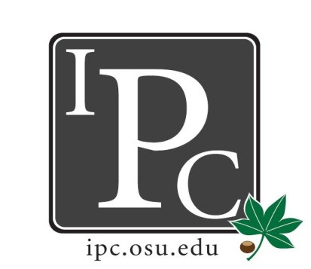

IPC Executive Committee, Justices, Senators
President: Matthew King

Inter-Professional Council

Senate Meeting

Ohio Union Senate Chambers

February 21, 2016

5:00 - 7:00pm

Vice President: Kevin Donnelly
Secretary: Noor Abushagur
Chief of Staff: Michael Ringle

- Guest Speakers
- Kim from MD Camp:
  - Program hosted by College of Medicine for 30-35 students (for disadvantaged HS students).
  - June 13-30th from 8am-5pm. Goal is to increase number of disadvantaged students in medical & health professions, with intro lectures for each of the colleges: dental, optometry, vet med, health & rehabilitation; includes shadowing opportunities for students.
  - Asking for $3000 from IPC

- President Update: Matthew King
- Graduate Student Trustee Selection committee: 20 applications have been narrowed down to 14 names. 14 students were interviewed, then got narrowed down to 5 names. Going forward from there. Of the 5 names, one of them was our own IPC Senator, Cristina Dickos! Yay!
- CSA: got reconciliation of $1000. IPC Funds from CSA were adjusted from 7% to 8.25%.

- Vice President: Kevin Donnelly
- Budget: Ride for World health cost us only $300 instead of $1100.

- Secretary: Noor Abushagur
- Will begin adding attendance records & pictures of senators to IPC website.
- HPS Update: Asim is still working on funding, no new updates.
- PR Chair Update: share the PDF facebook page to get the word out. Deadline Feb 26

- Chief of Staff Update: Michael Ringle
- Council of Enrollment of Student Progress needs an IPC rep: meets First Tuesday of month, at 3pm
  - Filled by Ashley Bulinski

- Chief Justice Update: Jeffrey Yu
- Feb 26 PDF deadline

- Social/Service Chair Update: David Gorenz
- Laser Tag was a success, 70 people showed up.
- IPC gmail was a great idea for organization.
- 8th annual soccer tournament: had 10 teams, Pharmacy school won. IPC raised $480 dollars for the Mid-Ohio Food Bank
- Gaswerks Social: Gaswerks loved us & wants us to have another event there, said they’ll give us 20% of profits made back to us.
- Volleyball tournament will be April 15th (Friday). Time is tentatively 6-9pm

- Outreach Chair Update: Kristin Zabrecky
- T shirt designs for next year: will be voted on next meeting.
- Senator Sweatshirts will be $10 each. Heather gray quarter zip with IPC emblem. (Actual cost is $28)
- PDF reminders – individualized posters will be sent out to each school

- New Business
- Resolution for MD Camp 2016: will be postponed until a resolution is provided
  - Might want to consider changing the name of “MD Camp” since it is now incorporating more than just Medical School now.
- Senator Appreciation: there's been a lot of great success this year, we want to celebrate! Renting a house in Hocking Hills for everyone on April 15-17. (funding for this is coming out of our social account)
- Pharmacy Event: now has been changed to appetizers at Hamptons at 8pm
- Charity event going on through the College of Pharmacy and their Alumni Association: Pharmathon 5K to support substance abuse awareness. The event is April 3rd.
- NCAA president will be here Feb26 at the union if anyone would like to go

Adjourn: 6:12pm

