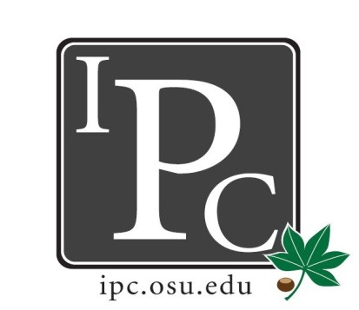

IPC Executive Committee, Justices, Senators
President: Matthew King

Inter-Professional Council

Senate Meeting

Ohio Union Senate Chambers

April 3, 2016

5:00 - 7:00pm

Vice President: Kevin Donnelly
Secretary: Noor Abushagur
Chief of Staff: Michael Ringle

- President Update: Matthew King
- Hocking Hills trip: you can still sign up. 18 people have signed up so far. It will cost $65 per person, minus $5 for every meeting you’ve attended this year. If you're unsure about your attendance, ask Noor.
- PDF Contract renewal: Kevin and Matt will be updating the contract starting this week. Goals:
  - To get at least the same amount of funding as before. For schools who have rollover money, Deans are just being asked to top off the amount to make sure each school starts out with $5000.
  - Multi year contracts so that we don’t have to renew every year
  - Increased funding from schools who have higher volume of applications (Medicine)
- We should start up some new committees:
  - Orientation committee to introduce IPC to the incoming students. We need to make sure all the schools are getting the same message. It’s not just Halloween and socials. The backbone of IPC is the committees we serve on for the university.
  - PDF review committee: reps from each school. Sticking with retroactive system.
- Internal committee appointments need to be figured out by May 1st. This is done by newly elected officials.
  - PR
  - Chief of staff
  - Social chair
  - Etc
  - Outreach chair: better need to manage the website
    - Have pictures of senators
    - Have attendance posted

- Vice President Update: Kevin Donnelly
- Still in thedark about HPS. We don’t have the 5k
- Swag: has the design ready for shirts to be ordered. Some can be given out at volleyball if they're ready by then. Mostly for at orientation next fall

- Secretary Update: Noor Abushagur
- Attendance

- Chief of Staff Update: Michael Ringle
- No updates

- Chief Justice Update: Jeffrey Yu
- PDF update: all grading has been done. Will be sent to Kerry and Renee. 108 total apps. Similar numbers to the Fall. Total requested was 63k. we funded 40% - 26k.
- Repeat applications: all went into the third tier. 20-25% of what they requested previously.

- Social/Service Chair Update: David Gorenz
- Volleyball in 2 weeks. $5 for mid Ohio food bank. Teams of 6, raffling off buckets of beer.
- 1712 meals were given from the money we raised from Soccer

- Outreach Chair Update: Kristin Zabrecky
- T-shirts: still waiting to hear back from when we’ll get the back. Hopefully will be here by the next meeting.
- All the new swag has been picked out
  - Sunglasses
  - Post it notes
  - Highlighters, etc. for orientation next year.

- New Business
- HPS: 60 people total. Last year was 150-165. Funded completely from the deans
  - 6k total. Don’t need any money from IPC.
  - Deans all meet the first Tuesday of every month
- Gifts for Graduating Senators
- Elections

Adjourn

