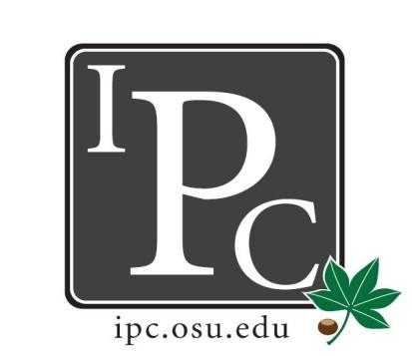
Inter-Professional Council
Senate Meeting
Ohio Union Senate Chambers

October 15th, 2017

IPC Executive Committee, Justices, Senators
President: Sara Adelman
Vice President: Kristin Zabrecky
Secretary: Sarah Gartner
Chief of Staff: Peter Yu
- Resolution
  - Indigenous People’s Day
    - Reconstitute Columbus Day (2nd Monday of October) as Indigenous People’s Day
    - Take out last WHEREAS? Let’s ask Alex
    - Opposition?
    - Would like to vote on November 19th, have him come and give a presentation

- President Update: Sara Adelman
- PDF Discussion
- Halloween
  - GET AMPED!!
  - Leads disperse to senators for them to sell at the school
  - $10 each
  - 21 and over event, get complimentary drink
- Bylaw Changes
  - Cabinet will work on bylaw changes, then present them in November 19th
  - Vote on changes on January 11th
- Free Speech Day
  - We can have safe and respectful conversations
  - Mr. Spencer conversation - should he be welcome to campus?
    - Would feel scared to have him here
    - School has responsibility to keep school safe, but don’t think it’s worth our money
    - Give platform to other side without giving to him
    - See more as a public safety issue
    - See more risk than benefit
  - Was there a student group that wanted him to come?
  - Is there a precedence for this type of speaker in the past?

- Vice President Update: Kristin Zabrecky
- Budget Sheet
- Halloween Venmo (@OSU-IPC)
- Breakfast Interview Substitutes
  - Tuesday, Wednesday, Thursday 8AM - Let Kristin know if you can help out!

- Secretary Update: Sarah Gartner
- Attendance

- Chief of Staff Update: Peter Yu
  - University Recreational Sports Committee Update
    - Losing Jesse Owens West soccer fields
  - University Senate Rules Committee Update
    - Discussed keys, getting rid of that you need the key
    - Service animals (was only seeing-eye dogs), updating rules
  - University Senate Update
    - Vote to change wording to add research faculty
    - Dr. Drake had Q and A about his vision for the 2020 plan
  - Need for alternate
    - Next Tuesday !0A for DLIT committee

- Chief Justice Update: Carolyn Chakuroff
  - PDF application update
    - Waiting for these from Kerry
  - BYLAW CHANGES
    - Application Dates
    - Look at adding something in saying seniors can’t apply the last semester
    - Can’t add in submit second request in cycle

- Social Chair Update: Olivia Grieszmer
- Bowling Night
  - November 17th

- Service Chair Update: TaLeitha Varner
- Soccer Tournament was a success - Congrats to Near The End from Pharmacy!
- Community Day
  - All schools represented, start thinking about preparing an activity for the day
  - Dr. J (VP for student life) is PUMPED!
    - Will talk to kids during event, can donate money/food if needed
  - March 3rd is set!

- HPS Chair Update: Jordan Vajda
- Dean’s Meeting November 22nd
  - Jordan’s bday!
- Full committee member end of October
  - Look out for the doodle
- Law Speaker Updates
  - Anna got a law speaker, still waiting to nail it down

- Outreach Chair Update: Matt Hamrick
- Donut Days were a success!
  - Give back any remaining IPC swag
- IPC Senator Jackets
  - Should be in by the next meeting

