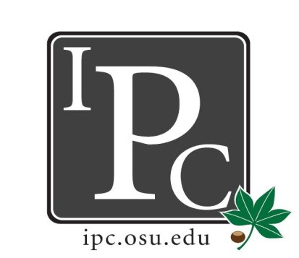

IPC Executive Committee, Justices, Senators
President: David Gorenz

Inter-Professional Council

Senate Meeting

Ohio Union Senate Chambers

October 16, 2016

5:00 - 7:00pm

Vice President: Kristin Zabrecky
Secretary: Noor Abushagur
Chief of Staff: Michael Ringle

- Speakers:
  - Psychiatry Student Interest Group: College of Medicine
    - Suicide is the 10th leading cause of death for all ages. This organization wants to co-sponsor a “REACH” Suicide Prevention training for professional students & allocate $100 for food/beverage service.

- President Update: David Gorenz
- IPC Tailgate was a success, we even had a snapchat filter whaaaat?!
- CBJ IPC Night: window closes two days before event, advertise to your constituents!
- Halloween Party: we have 1000 tickets for presales, each school will start out with 100 tickets & can reach out to David if you need more. Leads will let senators know how sales will be run within each school. We’ve already paid for the tickets so don’t lose any!! Students can pay with cash or make checks out to OSU IPC. Venmo account is “OSU-IPC”.

- Vice President Update: Kristin Zabrecky
- Budget

- Secretary Update: Noor Abushagur
- Attendance

- Chief of Staff Update: Michael Ringle
- No updates

- Chief Justice Update: Mike Friebe
- PDF presentation on what PDF is
- Vote: applications must be for events that have occurred during the most recent application window
- Vote: applications are due 6mo apart.
- Vote: time frame for open application window should be two weeks instead of 1mo.
- Vote: a student can apply for two applications annually
- We’ll continue voting on the rest of the changes at the next meeting

- Social/HPS Chair Update: Sarah Gartner
- Bowling: 102 attended. Last year was 60 people so good job. Cost $460, right under budget.
- Potential trivia night in January. Let Sarah know if you have any other ideas for socials you'd like to do
- HPS: waiting to hear back from Dental & Law deans

- Service Chair Update: Ashley Bulinski
- Give Kids a Smile received a check for $425 for the soccer tournament

- Outreach Chair Update: Mary McKeever
  - Donut Days are done!

- New Business
  - Everyone exercise your rights to vote & go vote on November 8th!
  - Vote: Resolution for $100 for REACH training
    - Motion passes

Adjourn: 6:27pm

