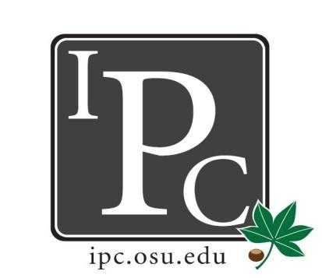

IPC Executive Committee, Justices, Senators
President: Sara Adelman
Inter-Professional Council
Senate Meeting
Ohio Union Senate Chambers

February 11th, 2018

Vice President: Kristin Zabrecky
Secretary: Sarah Gartner
Chief of Staff: Peter Yu

- Speakers:
  - Resolutions
    - Governmental Affairs Ad Hoc Committee
      - Help research and manage that pertain to governmental affairs within the university that directly affect professional students
      - Working with governmental affairs
      - PASSED 30 yes, 1 abstain
    - Black Law Students Association
      - Asking for Soul Food Luncheon at February 27th at 12P
      - Talk and build community
      - $500 for fried chicken, mac n cheese, cornbread, $150 for promotion
      - Last year spent around $850 for 163 people
      - Charging $10 for students, $15 for faculty - goes toward raffle
      - Have applied for CSA funding, close to limit of funding due to other events
      - PASSED 29 yes, 2 no, 1 abstain

- President Update: Sara Adelman
- Credit Hours Audit Committee
  - President and provost trying to get affordability for graduate students, figuring out how to do that
  - Working with Kyle Hickman - give any grievances about credit hours
  - How is our tuition going for our credit hours? Want to understand this further
- Affordability (capital campaigning)
  - Provost just received binder full of ideas from Deans on where they would want capital campaigning to go → where the funding will go
  - But what are the needs of your facilities? Anything to subsidize?
  - Filter to Kyle or Sara
- Mental Health
  - Grad/prof aren’t getting bubbled up… but don’t know WHAT the problem is!
  - Availability of practitioners, hours are 9 to 5 (makes it difficult) for embedded counselor, psychiatrist designated to professional schools, dental counselor
  - Wellness groups? Expand to over all the professional schools (not mental health)
  - CCS specific to professional schools!
- PROSPER Act
  - Introduced to house - eliminate grad plus, get rid of public loan forgiveness, get rid of work study
  - Working with governmental affairs against it
  - Pushing to house floor this Spring
  - Please work to write letters against it
  - Governmental affairs talk about this at next meeting

- Vice President Update: Kristin Zabrecky
- Budget
- Casino Night April 7th

- Secretary Update: Sarah Gartner
- Attendance
- Hocking Hills Trip March 23-25th
- Blue Jackets March 22nd
  - Professional panel Q&A
  - Tickets $30, flyer
  - Ask about food vouchers
  - Make FB event

- Chief of Staff Update: Peter Yu
  - Committee Updates
    - Alex Lee (Diversity)
      - BART report for any bias you may be facing
    - Spenser Bowen (UITL)
      - Institute endorsement for whatever you want, under each college
      - Will talk to colleges to determine exact endorsements
    - Sara Adelman (Council on Sustainability)
      - Fund sustainability projects here and regional campuses
      - Increased use of hand dryers instead of paper towels
      - Compostable waste research
    - FIFA Athletic Council
      - Lowering cost to $9 from $14
  - Committee Replacements/Absences
    - Parking Committee Tuesday 3:30-5P Bricker Hall Room 200
      - April 13th (ish) as well)

- Chief Justice Update: Carolyn Chakuroff
  - Kyle reformatted bylaws on website!
  - New check policy → 90 days until check expires
  - PDF on website! Start advertising!
  - New PDF logo

- Social Chair Update: Olivia Grieszmer
- IPC Social Lucky’s Feb 23rd 9P
  - Drink specials same, same DJ
- Roller Skating
  - Either April 12th or 13th

- Service Chair Update: TaLeitha Varner
- Community Day March 3rd
  - Tie up loose ends for that. Upwards for 40 high school students!
- Volleyball Tournament April 14th

- HPS Chair Update: Jordan Vajda
- HPS NEXT SATURDAY! - February 17th from 9A-3P
  - Max 150 students

- Outreach Chair Update: Matt Hamrick
- Donut Day Success!
- T-shirt Designs for next year
  - IPC ohio sign (white on red), Contact Hamrick.78 for T-shirt ideas

- New Business?

Adjourn

