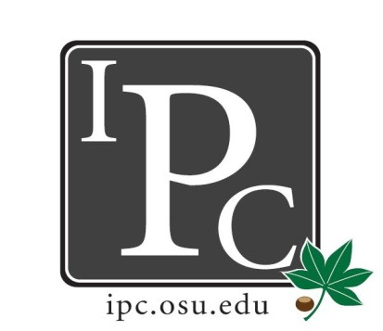

IPC Executive Committee, Justices, Senators
President: David Gorenz

Inter-Professional Council

Senate Meeting

Ohio Union Senate Chambers

February 12, 2017

5:00 - 7:00pm

Vice President: Kristin Zabrecky
Secretary: Noor Abushagur
Chief of Staff: Michael Ringle

- Speakers:
  - Yeonjung Park on behalf of MD Camp:
    - 3 week summer program intro to medicine and health professions geared toward under-represented minorities and/or socioeconomically disadvantaged high school students
    - requesting $3,500 to sponsor five full student scholarships
  - Sara Adelman on behalf of PODEMOS
    - student led organization dedicated to providing healthcare services to underserved residents of rural Honduras (bi-annually)
      - dental students only go on one trip only
      - 800-900 patients seen for 5-day period
    - Requesting $3000 to subsidize student trip fees (cost is $500/student for 1 week, includes meals, hotels, security. Not including airfare)
    - Trip dates: December 26- Jan 1 (winter) and end of May

- President Update: David Gorenz
- The exec board has been meetings with Deans to renew the PDF. So far we’ve met with 3 of the deans and they have renewed the application.
- Senator Social: look for upcoming email with more details
- Nominations for next year’s Executive Board will happen at our next meeting. If you're interested in what David, Kristin, & Noor do – reach out and ask!

- Vice President Update: Kristin Zabrecky
- Budget

- Secretary Update: Noor Abushagur
- Attendance
- Send a photo of yourself for the attendance powerpoint.
- Update from Mary McKeever (outreach): donut days went well overall. If we get more funding from CSA, we will have another one sometime in April.

- Chief of Staff Update: Michael Ringle
  - Expect an email from Michael regarding openings in committees. If you are not in a committee, you must get on one!
  - The ADHOC committee (for prof student housing) has set their meetings:
    - Feb 20th 3pm-4pm
    - March 1st 7-8pm

- Chief Justice Update: Mike Friebe
  - PDF application opens Feb 24 – March 10. Keep advertising!

- Social/HPS Chair Update: Sarah Gartner
- Lazer Tag: 65 people showed, everything went smoothly!
- HPS on Saturday, February 25th 9-3pm

- Service Chair Update: Ashley Bulinski
  - Volleyball tournament Friday April 14th

- New Business?
  - Vote: MD Camp
    - Amendment: we cannot fund scholarships, asking MD camp to allow IPC to fund program operating costs instead
    - We will wait until next meeting to vote because we want an itemized list of expenses from the event so we can decide what to fund (instead of scholarships)
  - Resolution: PODEMOS
    - Amendment: we cannot fund scholarships, asking PODEMOS to allow IPC to fund program operating costs instead
    - Approved for $1500 to cover operating costs
Adjourn 6:24pm

