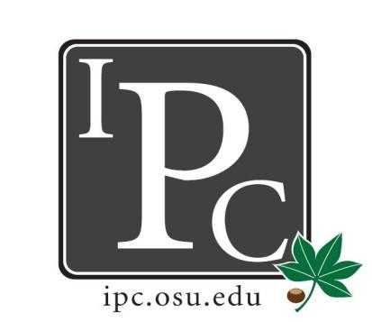

IPC Executive Committee, Justices, Senators
President: Sara Adelman
Inter-Professional Council
Senate Meeting
Ohio Union Senate Chambers

March 4th, 2018
Vice President: Kristin Zabrecky
Secretary: Sarah Gartner
Chief of Staff: Peter Yu

- Speakers:
  - PODEMOS resolution
    - Speaker Brandon
    - Biannual brigades to Honduras. 900 patients per trip.
    - Medical, dental, pharmacy students
    - Asking $3000 to go towards hiring additional Honduran staff and improvements in chronic care program
    - Originally had $1500 in years past, but now have chornic care program and increase in patients
    - Planning March Madness Tournament, spread the word
    - Voting: 29 yes 1 abstain PASSED
      - Change resolution to Chronic Care Program Medical Supplies and Equipment
  - Professional School Orchestra Resolution
    - Medical, optometry, law, nursing
    - Practice once per week, do 2 concerts
    - Asking for food for the concerts
    - Bring in around 60 people with 30 musicians (90-100 people total)
    - Receive funding from Medicine and the Arts but that goes towards music stands and music
    - Takes place at medical school, but open to everyone (free event)
    - $200 for pizza (Coke fund will apply for food)
    - Will hang banner
    - March 23rd 12-1P Meiling
    - Voting: 28 yes 1 abstain PASSED

- President Update: Sara Adelman
- Mental Health Survey, Grad/Prof student survey
  - Talked about lack of availability last time, how should we survey them?
  - Send out survey to understand mental health aspect of it
- SAF Committee - Muhammad Soofi
  - Ad Hoc committee from CSA
  - $4.4 million dollars to distribute it
  - IPC has been trending down in money that we receive
  - Proposal for $60,000 funding for IPC → get staff member in office solely for IPC
- Gov Affairs Committee
  - Working to meet with the office of governmental affairs
- Affordability Initiative - Kyle Hickman
  - Meeting with assistant provost Brad Harris
  - See breakdown of fees
  - Looking for help to tag along (Hickman.209)
- University Senate Steering Committee
  - Work with Ben Givens who drafted a call to the University to require sexual misconduct training for students, faculty, and staff

- Vice President Update: Kristin Zabrecky
- Casino Night April 7th
  - Black Diamond Casino to work out budget
- Elections March 25th

- Secretary Update: Sarah Gartner
- Attendance
- Hocking Hills Senator Social March 23rd-25th
- Columbus Blue Jackets Night March 22nd - Janice and Nikki
  - Sold 15 tickets so far, need 75 to keep speaker panel
  - Promote it!! Bring it up in class
  - $30 for ticket, speaker panel, and $5 food voucher

- Chief of Staff Update: Peter Yu
  - Council of Student Affairs
    - Need someone at meeting 3:30 to 5P in Spinx Leadership Suite

- Chief Justice Update: Carolyn Chakuroff
  - Spread the Word!! PDF open March 9th-23rd!
  - New PDF Logo

- Social Chair Update: Olivia Grieszmer
- Lucky’s Social Success!
- Roller Skating Night April 13th Date
  - 7 to 10P on Friday
  - Waiting to hear back on group pricing

- Service Chair Update: TaLeitha Varner
- Community Day Success! - feedback
  - 9 students showed up, very attentive and engaged
  - Good things
    - Loved the pets and the mock trial
  - Difficulties?
    - Transportation was challenging, parents didn’t come
      - Could utilize social change for transportation
    - Later start time
- Volleyball Tournament April 14th
  - 5P start time, entrance fee $5 per person

- HPS Chair Update: Jordan Vajda
- Health Professional Summit Success!
  - Pharmacy did great, highest numbers
- HPS Committee Updates
  - Name change to Inter-Professional Summit
- New Committee for Next Year?
  - Chair has to be filled by May 1st

- Outreach Chair Update: Matt Hamrick
- Outreach for Blue Jackets Night and PDF
  - Facebook event, go up and talk to the people
- T shirts
  - Waiting for design approval by OSU

- New Business?
  - Nominations for President, VP, and Secretary → remain open until next meeting, email Kristin!
    - President: Sarah Gartner
    - VP: Matt Hamrick
    - Secretary: Anna Crisp, Kyle Hickman
  - Vote on resolutions

Adjourn

