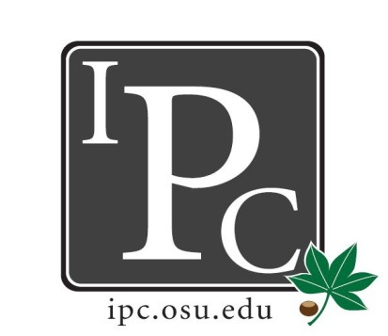

IPC Executive Committee, Justices, Senators
President: Matthew King

Inter-Professional Council

Senate Meeting

Ohio Union Senate Chambers

October 25, 2015

5:00 - 7:00pm

Vice President: Kevin Donnelly
Secretary: Noor Abushagur
Chief of Staff: Michael Ringle

- Guest Speakers
- Alex Lux & Garrett Lambert on behalf of College of Pharmacy Chili Cook-off
  - Annual event to raise money for charitable pharmacy of Central Ohio, provides free medications for those in need. Last year, raised $4500 for charitable pharmacy. This year, requesting $750 to offset the cost to cooks. Cooking teams volunteer their time & food. Most teams spend $50-100 every year. This would raise participation, which would raise more money for Charitable Pharmacy. In past years, they’ve had participation from College of Medicine, College of Vet Med. Funds are distributed on a basis of reimbursement.
- Muhammad Soofi on behalf of Buckeye Blanket Bash
  - Annual program to make fleece blankets for cancer patients at The James. One-day charity event where volunteers make blankets for patients at The James & Nationwide. This past year, they made enough blankets to give one to each bed at The James. All school are welcome to join in volunteering for this event. Physicians & survivors come in to speak to volunteers, local bands come to play live music, etc. Last year had over 300 volunteers & made over 300 blankets.
  - This year’s event will be on January 15 at Ross Heart Hospital. If any professional schools have cancer survivors or entertainment groups that would like to present, please let the organization know.
  - This year, there are more supplies needed. Asking for $500 for blanket supplies.

- President Update: Matt King
- Senate Steering: IPPC policy has been a mess. Editing committee is not supposed to make any substantive changes. Let Matt know if you’d like to be more involved in this issue.
- Sales are going well for Halloween ticket sales. We need volunteers at the door, let Matt know if you can volunteer.

- Vice President Update: Kevin Donnelly
- Budget hasn’t changed, except for the Give Kids a Smile resolution from last week. T-shirts should be arriving soon.

- Chief Justice Update: Jeff Yu
- We are two weeks into the application window, there is one week left. End date is October 30. Then the IPC office will process the applications & get them graded.
- At next senate meeting, Jeff will provide numbers of submitted applications & how much money will be allocated. Leads, please send out another email to remind students that there is one more week left.

- Chief of Staff Update: Michael Ringle
- We have an opening for Ohio Union council. Meets on Mondays at 3:30pm. Contact Michael if you are available to fill this position.

- Social Chair Update: David Gorenz
- Village Idiot social was very successful
- Bowling had about ½ of how many people attended last year, but it was still fun.
- Halloween will be the last social event of the year.

- Service Chair Update: Chelsea Devitt
- Soccer tournament will be postponed until the spring

- Outreach Chair Update: Kristen Zabrecky
- Keep an eye out for the Outreach Breakfast. Will happen around finals.

- PR Chair Update: Caitlin Thompson
- Facebook now has pictures of where the IPC office is, for those turning in PDF applications

- New Business
- VOTE: Resolution for Chili Cook-off. Motion Passes
- VOTE: Resolution for Buckeye Blanket Bash. Motion Passes
- Asim talks about HPS. Tentative date is April 2nd 8-5pm. Will be at Fawcett Center. Event is titled “Back to the Basics: What is Mental Illness?”. More details will be provided soon. Reach out to Asim if you'd like to be involved in this committee.

Adjourn: 6:29pm

