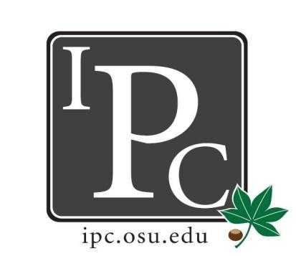

IPC Executive Committee, Justices, Senators
President: Sara Adelman
Inter-Professional Council
Senate Meeting
Ohio Union Senate Chambers
January 21st, 2018
Vice President: Kristin Zabrecky
Secretary: Sarah Gartner
Chief of Staff: Peter Yu

- Speakers:
  - PILF Resolution
    - Maddie Rettig and Max Schmidt
      - $500 for annual auction
      - For public law internships for students
      - Fund 11 fellows total (10 $4,00 total, 1 part time $2,000)
      - Mostly attended by law students and faculty, but expand audience
    - Propose spending goes towards food and facilities, IPC banner, invite all professional students
    - Pass 28 yes, 1 abstain
  - SHINE (Somali Health Initiative for Nutrition Education) Field Trip Resolution
    - Aaron Koenig
      - Contact Shine.osumc@gmail.com
      - Can add Flyer, event is February 25th
    - At least one other person to fill panelist from another school

- President Update: Sara Adelman
- Transitions in Leadership
  - Start reaching out now
- Governmental Affairs
  - Necessary role in the governmental affairs of OSU
  - Do research, able to go to meetings
  - Be the VOICE of IPC for these government policies
  - President sitting as chair
  - Committee until 2020 and then dissolve if unnecessary
  - Time commitment? Once a month or so
- DACA Liaison - Bo Marshall, marshall.572@osu.edu, 614-688-8492
  - Official DACA liaison. Get this distributed to student life deans to get to whole student body
- Tax Bill Updates
  - None of the scary stuff was included!
- IPD Resolution
- Mental Health
  - Come directly to Sara if any needs aren’t being met for mental health

- Vice President Update: Kristin Zabrecky
- Budget

- Secretary Update: Sarah Gartner
- Attendance
- New Law Senator
- IPC Senator Social… new date? March 24th
- Blue Jackets Night - March 22nd → Nicole?

- Chief of Staff Update: Peter Yu
  - Committees that need filled
    - University Senate Fiscal Committee: Tuesdays 1-3 p.m.
    - Council on Distance Education, Libraries, and Information Technology (DELIT): January 23 (Tuesday), 10:00 – 11:30, 204 Thompson Library; February 28 (Wednesday), 10:30 – 12:00, 150 Thompson Library; March 27 (Tuesday), 10:00 – 11:30, 204 Thompson Library; April 24 (Tuesday), 10:00 – 11:30, 150 Thompson Library; May 23 (Wednesday), 10:30 – 11:30, 150 Thompson Library.​
    - Strategic Programming Grant committee: Wednesdays at 2:30 p.m. 1-2 hours long. The meetings will be concluded in 3 months.
  - Committee Updates
    - Parking Advisory Council (Lauren)
      - Tuesday February 13th from 3-5P, Bricker Hall NEED attendee
    - Student Legal Services Advisory Board (Olivia)​
      - Richard Spencer legality of that
      - Expanding to the space next door → expand immigration
      - Will it increase the fee?
    - Athletic Council (Kristin)
      - Award two students scholastic Achievement
      - Football seating?
    - Trustee Selection Committee (Sara, Kristin, Sarah)
      - Board of Trustees for OSU
      - Met a couple times, working through applications, interviewees will get an email here soon.
      - Will interview in February, then send 5 to go to Governor for them to choose
    - Alumni Distinguished Award Committee
      - One Dentistry and Medicine faculty in it!

- Chief Justice Update: Carolyn Chakuroff
  - PDF checks
    - March 9th application will be due
    - Checks still rolling out
  - Review Constitution Amendments
    - Look at Carolyn’s notes
    - 100% yes approved

- Social Chair Update: Olivia Grieszmer
- Socials for this year
  - Lucky’s on February 23rd
  - Roller Skating April 13th

- Service Chair Update: TaLeitha Varner
- Community Day Updates
  - Waiver for kids
- Volleyball Event
  - February 6th at Woodland’s

- HPS Chair Update: Jordan Vajda
- HPS updates
  - Need final numbers 5 days in advance

- Outreach Chair Update: Matt Hamrick
- Donut Day February 12th-16th … maybe first
- New senator jackets in if you haven’t picked them up

- New Business?

Adjourn

