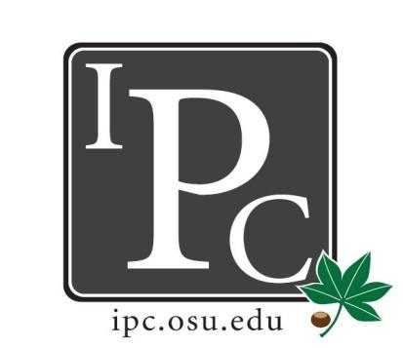
Inter-Professional Council
Senate Meeting
Ohio Union Senate Chambers
September 17th, 2017

Welcome Back - Don’t forget your namecard!

- President Update: Sara Adelman
- Welcome new senators!
- Summer updates on parking and graduate/professional housing
  - Parking
    - Cannon drive is closed
    - Let us know continual feedback on the parking
  - Housing
    - Took down grad/prof housing
    - Currently taking offers → looking for feedback
- Nametags!
- IPC Newsletter
  - To Do: newsletter for this month → depends on when Sara can get trained

- Vice President Update: Kristin Zabrecky
- Budget for this upcoming year
- Memorandum of Understanding
  - Using for accountability of the organizations we give money for

- Secretary Update: Sarah Gartner
- Attendance policies
  - To do: Send out senator handout to IPC roster
- Senator photos
  - To do: Send to osuinterprofessionalcouncil@gmail.com

- Chief of Staff Update: Peter Yu
  - Introduction to committees
    - will have people update on committees and ask
    - Will implement regular committee updates
  - Need Committee senators
    - University senate fiscal committee (tuesdays from 1:30-3:30)
    - Council on physical environment (third thursday of each month from 2-3P)
    - Sexual Civility Council → Oct 4th 1-2:30

- Chief Justice Update: Carolyn Chakuroff
  - PDF standing rules
    - Need to tweak new guidelines
  - PDF cycle close Sept 22nd - let people know!
  - Still need Law Justice → found at meeting, Dante

- Social Chair Update: Olivia Grieszmer
- Lucky’s Social updates
  - Great turnout!
- Tailgate with Psi Omega (Sept 23rd 12:00PM)
  - Kegs and eggs
  - Changing to 9:00AM start since game now starts at 12P
- Halloween Party at Park Street (Oct 27th 9:00PM)
- Bowling sometime
- PR:
  - instagram: osu_ipc
  - twitter: @ipc_at_OSU

- Service Chair Update: TaLeitha Varner
- Soccer Tournament (Oct 8th 12:00-4:00PM)
  - To Do: event on facebook
- Community Day (spring)
  - Reach out to Columbus community to empower young people to become professionals
  - Looking for new committee members

- HPS Chair Update: Jordan Vajda
- Health Professional Summit Updates
  - Disparities in Health February 17th, 2018
  - Promote/summarize to the professional school alumni magazines
  - Certification?

- Outreach Chair Update: Matt Hamrick
- Outreach chair overview
- T-shirts and swag
  - Organize boxes for swag (badge clips, coffee mugs, sunglasses)
  - Schools have allocated T-shirts
- Donut Day
  - 1st week in october

- New Business?

