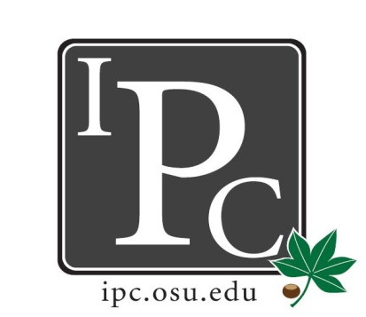

IPC Executive Committee, Justices, Senators
President: David Gorenz

Inter-Professional Council

Senate Meeting

Ohio Union Senate Chambers

January 22, 2016

5:00 - 7:00pm

Vice President: Kristin Zabrecky
Secretary: Noor Abushagur
Chief of Staff: Michael Ringle

- Speakers:
  - Varun Rawal on behalf of Buckeye Blanket Bash
    - Annual one day event. COM makes fleece blankets for the community. Free food to volunteers, live music, & it’s a collaborative event for the community to promote cancer awareness.
    - Asking for $500 funding for expenses for making blankets
  - Peter Yu on behalf of Professional School Orchestra
    - Originally the Humanism in Medicine Orchestra but has now expanded to include students from all professional schools & is now the “Professional School Orchestra”
    - Currently gets $1000 from Humanism in Medicine for running the program but is asking for
      - $500 for food during performances
      - $500 for drum set
      - $300 for banner
  - Peter Yu on behalf of Cancer Disparities Roundtable
    - March 17: roundtable event with 3 experts, 50 students with lunch. Will have a discussion about cancer disparities.
    - Only IPC students will be invited, similar to last semester’s Surgeon General David Satcher event

- President Update: David Gorenz
  - Buckeye Village is housing for grad/prof students with families. 1/5th of residents are being moved out for construction. The remaining 4/5th of students are concerned with noise problems, etc. CGS feels like grad/prof students are being forgotten because undergraduates are getting a lot more funding for housing. CGS is making an AD HOC committee & wants some IPC senators to serve on this committee as well.
    - Goal is to have a plan ready to go for Board of Trustee meeting on Nov 2017. If you’re interested in serving on this committee, let David know.
  - Senator Socials: we have a budget around $1000 for a senator-only social. What would you guys like to do? Email David with ideas. Options:
    - Hocking Hills
    - Dinner
    - Laser Tag / something interactive
  - Casino Night will be April 15 or 29. Will cost us $1000 extra to book the 15th but that would probably have better attendance than the 29th (which would be during finals week)
  - Looking for create a video for HPS for free… know anyone who would be interested in doing this? Let David know.

- Vice President Update: Kristin Zabrecky
- Budget

- Secretary Update: Noor Abushagur
- Attendance

- Chief of Staff Update: Michael Ringle
  - Contact Michael if you’ve had a change in schedule & need to go to new committee.

- Chief Justice Update: Mike Friebe
  - Application opens in about 1mo!
  - All info is available online – deadline March 10th

- Social/HPS Chair Update: Sarah Gartner
- HPS Presentation
- Feb 3 – IPC Laser Tag (already have 60 signed up – only 80 slots)

- Service Chair Update: Ashley Bulinski
- Volleyball Tournament in April – will be the 7th or 14th

- Outreach Chair Update: Mary McKeever
- Donut Days: Feb 6-10
- Will send survey out for options on what we want for Senator swag this upcoming year.

- New Business?
  - Vote on Resolutions
    - Buckeye Blanket Bash: motion passes for $500
    - Professional School Orchestra:
      - $500 to Drumset
      - $200 for food
      - $300 for banner
    - IPC Cancer Disparities Roundtable: decided to move the vote to next meeting to hear back from provost for funding & wait to hear for a new date that would work better for IPC students.

Adjourn: 6:40pm

