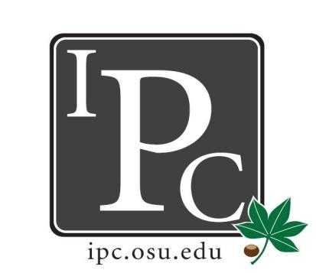

IPC Executive Committee, Justices, Senators
President: Sara Adelman
Inter-Professional Council
Senate Meeting
Ohio Union Senate Chambers

March 25th, 2018
Vice President: Kristin Zabrecky
Secretary: Sarah Gartner
Chief of Staff: Peter Yu

- Speakers:
  - College of Optometrists in Vision Development Resolution
    - Vision Therapy Equipment Craft Night March 28th, 2018
    - Asking for $345 for discretionary funds (300 fusion strings and beads, 300 push up sticks, shipping for prism set, random dot stereo, tranaglyph
    - Teaching Dr. Owusu speak about his experience at OSU as well as creating supplies for him to take back home to Ghana
    - Open to all professional students
  - Student Volunteer Optometric Services to Humanity Resolution
    - Akim-Akroso, Ghana Service Trip August 4th-11th, 2018
    - 600-900 patients in a week, 15-20 optometry students, adding in ophthalmologists this year
    - Asking for $2,200 including $1,200 for doctor flights, $1000 for lens blanks, sunglasses, and dilating agents
    - $200 cost for optometry after raising funds in other ways
    - Purchase supplies this fiscal year
    - Discussion
      - Acting clause is 2 or more inter-professional schools… is this right?
      - Can we reassess the Constitution to better fix our resolutions

- President Update: Sara Adelman
- Grad/Prof Survey
  - PLEASE fill out!
  - Allows for assessment of the students
  - Push through social media and your friends
- Gov Affairs: first meeting 4/10/18
- Affordability: reminder to send “capital” ideas to Kyle
  - Determine how capital campaigning money
- Chair positions
  - Must appoint chair positions by May 1st
- Inauguration 4/15/18
  - Superlatives

- Vice President Update: Kristin Zabrecky
- Casino Night April 7th
  - All of the electronic goodies!
  - In the performance hall
- Budget Update

- Secretary Update: Sarah Gartner
- Attendance
- Blue Jackets Night (Nikki and Janice)
  - 50 people
  - Unable to do the panel
  - Thinking about doing it the Fall next year (November)
- Hocking Hills Senator Get Away

- Chief of Staff Update: Peter Yu
  - Committee Updates
    - Sexual Misconduct resolution did pass at university senate
      - May have to do training for this in the future
    - Indigenous People’s day
      - Recognize (not observe) the day, and went through
      - May not be specific day

- Chief Justice Update: Carolyn Chakuroff
  - PDF Updates
    - Due Friday!
    - Will talk about it at next meeting

- Social Chair Update: Olivia Grieszmer
- Roller Skating Night April 13th 7-10pm at SkateZone 71
  - $5 per person, IPC will cover $3

- Service Chair Update: TaLeitha Varner
- Volleyball Tournament April 14th 6pm at Woodlands
- Facebook event and team signup coming soon!
- Leads send choice of charity/organization
- $5 per person

- HPS Chair Update: Jordan Vajda
- Health Professionals Summit Transition
  - Will need new chair and committee
  - Designate who from each professional school will be on the committee

- Outreach Chair Update: Matt Hamrick
- T-Shirts finalized, waiting from approval for office
  - 550 shirts
- Promotion items/swag for next year
  - IPC phone wallet cases, ID badges
  - Let Matt know if there is any others!

- New Business?
  - HPS Resolution
  - Affordability Resolution
  - Elections

Adjourn

